Manage Your ROTI*
*Return on Time Invested
Understand and manage your time quadrants. Your goal: Spend more time in Quadrant 2, work to minimize items in Quadrant 2. Actively manage the other two quadrants.
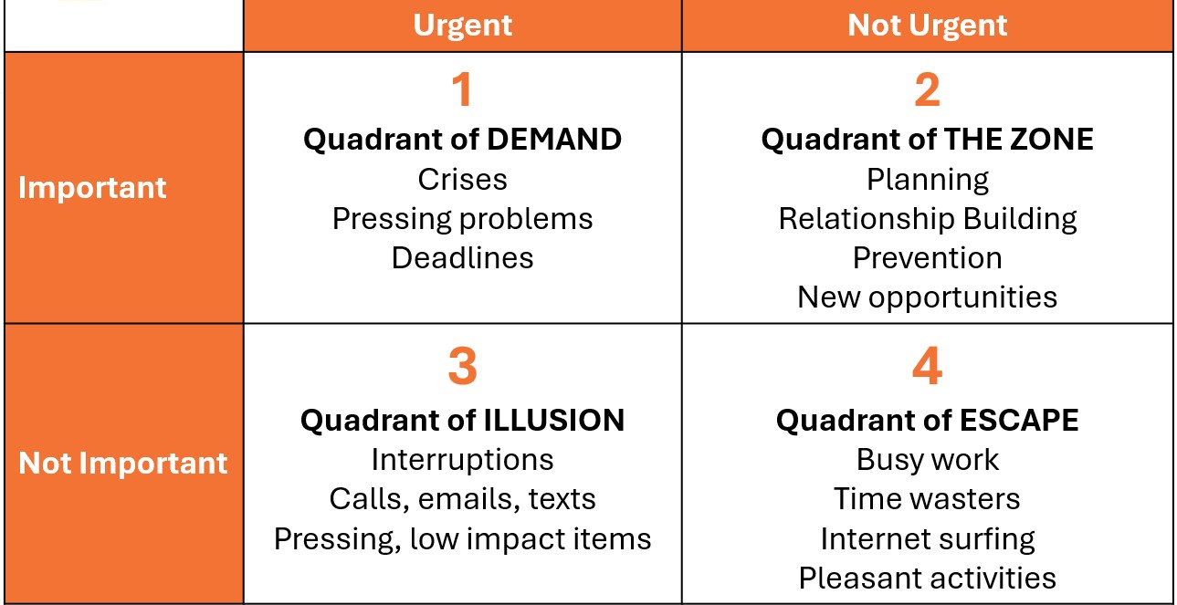
Quadrant 2 time management from the book, 7 Habits of Highly Effective People

Optimize your ROTI (Return on Time Invested)
Identify your time stealers | Implement high ROTI practices
- Credit cards on file
- Collect deductibles at time of service
- Submit claims weekly
- Block time for marketing/admin tasks
- Track & manage revenue process tasks

